**SENTIMENTAL ANALYSIS OF REVIEW TEXT – GRAND LUX CAFE**

The primary aim of the project was to analyse Yelp datasets including restaurants in the city of Las Vegas.

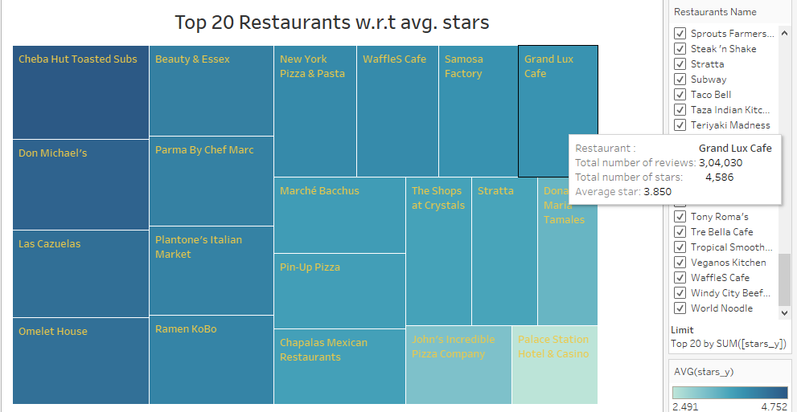

Grand Lux Café has the highest number of reviews (Suggesting high traffic) with the avg. rating of just 3.8. Therefore, we decided to choose Grand Lux Café (GLC) to perform analysis and answer some business questions accordingly.

**The question whether, when does GLC need to hire staff/ increase employment to meet the needs? In what months does GLC require high stock in food?** Is answered by the tableau representation of the month/ quarter wise number of reviews distribution answers the above question successfully.

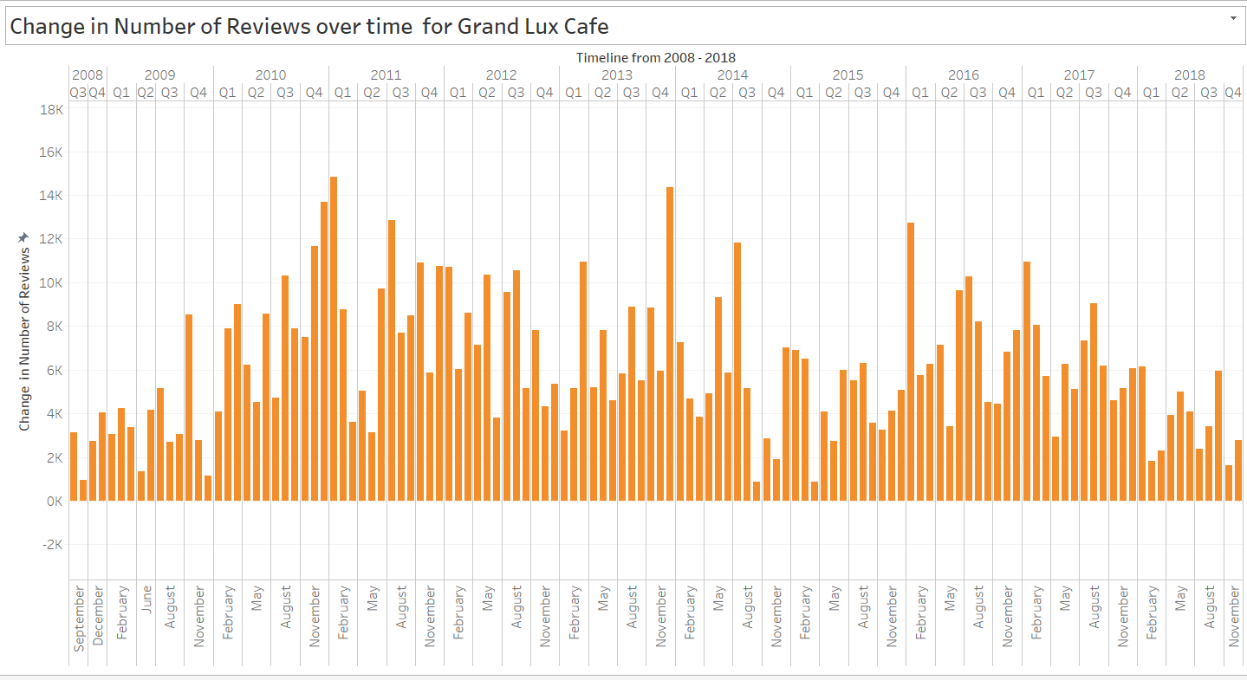

**But what explains the 3.8 rating?** We plotted the number of reviews w.r.t ratings throughout its year of operation shows a drop in the ratings yearly and monthly.

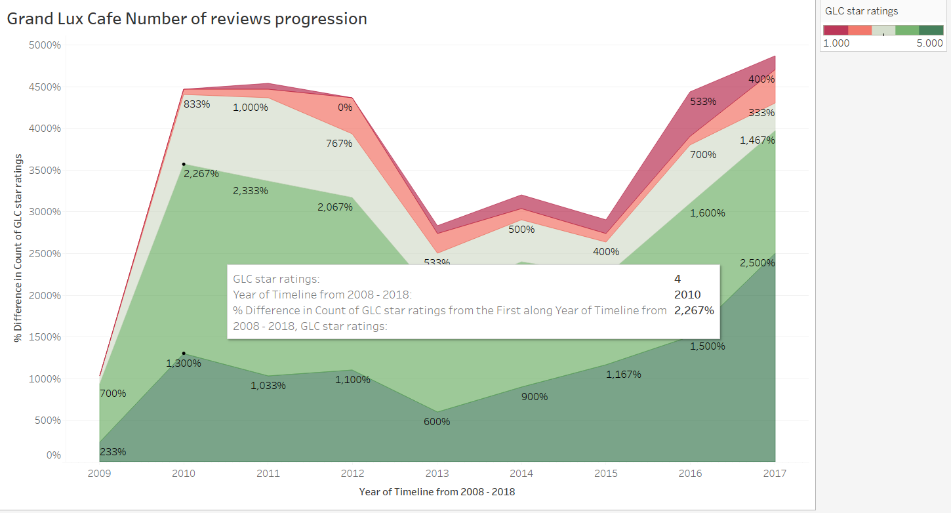

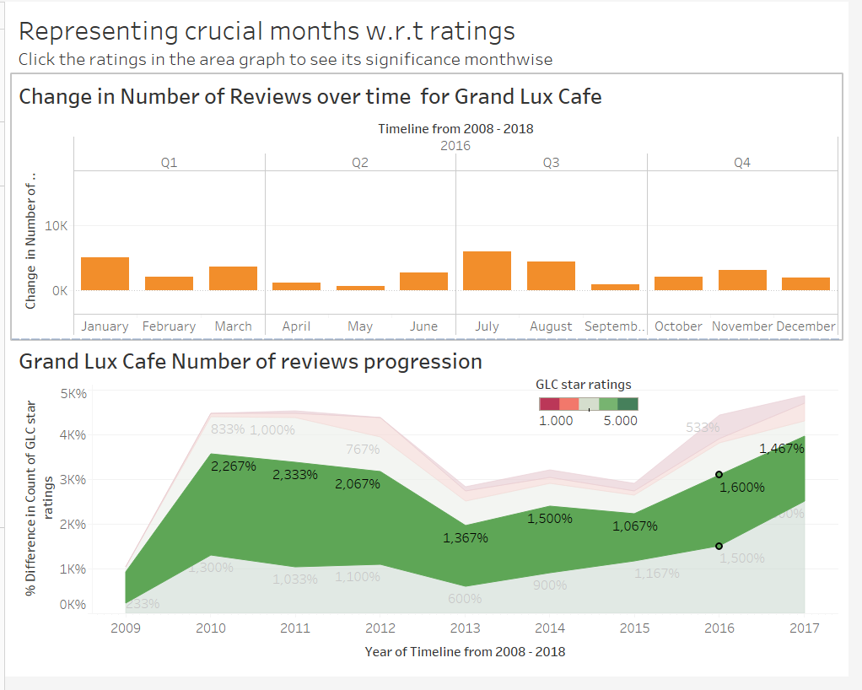

It is due to this drop the overall ratings of GLC would have reduced.

**What could be the factors that led to this downslide?** to answer this question, we performed sentiment analysis on the GLC review text in python to generate positive and negative review word clouds given us insights of what works and what doesn’t for Grand Lux Café.

